Docker testing and integration
Screenshot – Cloning the GitHub Repository
Command: git clone
Description:
Successfully cloned the GitHub repository to the local machine. All project files were downloaded and are ready for Docker testing and integration.

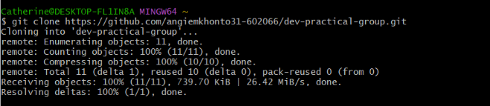

Screenshot – Accessing the Docker Project and Building the Image
- cd dev-practical-group
- ls
- cd docker-python-app
- ls
- docker build -t python-app .
Description:
Accessed the Docker project directory, verified the project files (Dockerfile and app.py), and successfully built the Docker image named python-app.

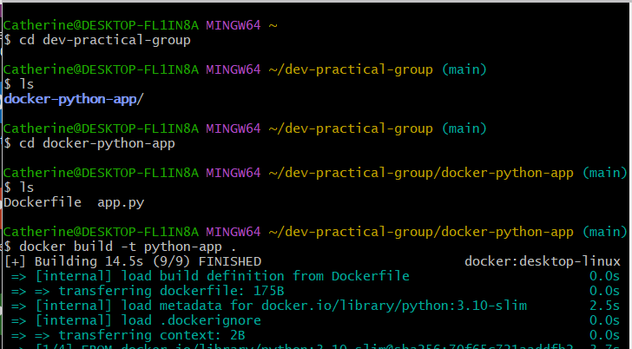

Screenshot – Running the Docker Container
Command:
docker run python-app
Description:
Successfully ran the Docker container and verified that the application executed correctly by displaying the message "Hello from Docker!". This confirmed that the Docker image was functioning as expected.

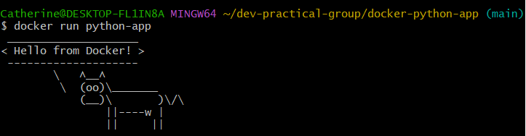
Screenshot – Viewing Docker Images
Commands: docker images
Description:
Displayed the available Docker images and verified that the python-app image was successfully created and tagged as latest. This confirmed that the Docker image was built successfully and is ready for execution.

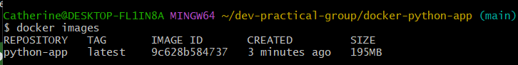
Screenshot – Viewing Docker Container History
Command: docker ps -a
Description:
Displayed all Docker containers and their status. The output confirms that the python-app container executed successfully and exited normally with status Exited (0), indicating that the application ran without errors.
